Reg. č.: CZ.02.2.69/0.0/0.0/16_015/0002362

Úprava kurikula předmětu Struktura a funkce lidského těla, část lokomoce.
Autor: kolektiv autorů pod vedením prof. MUDr. Petra Zacha, CSc. z Ústavu Anatomie 3. LF UK

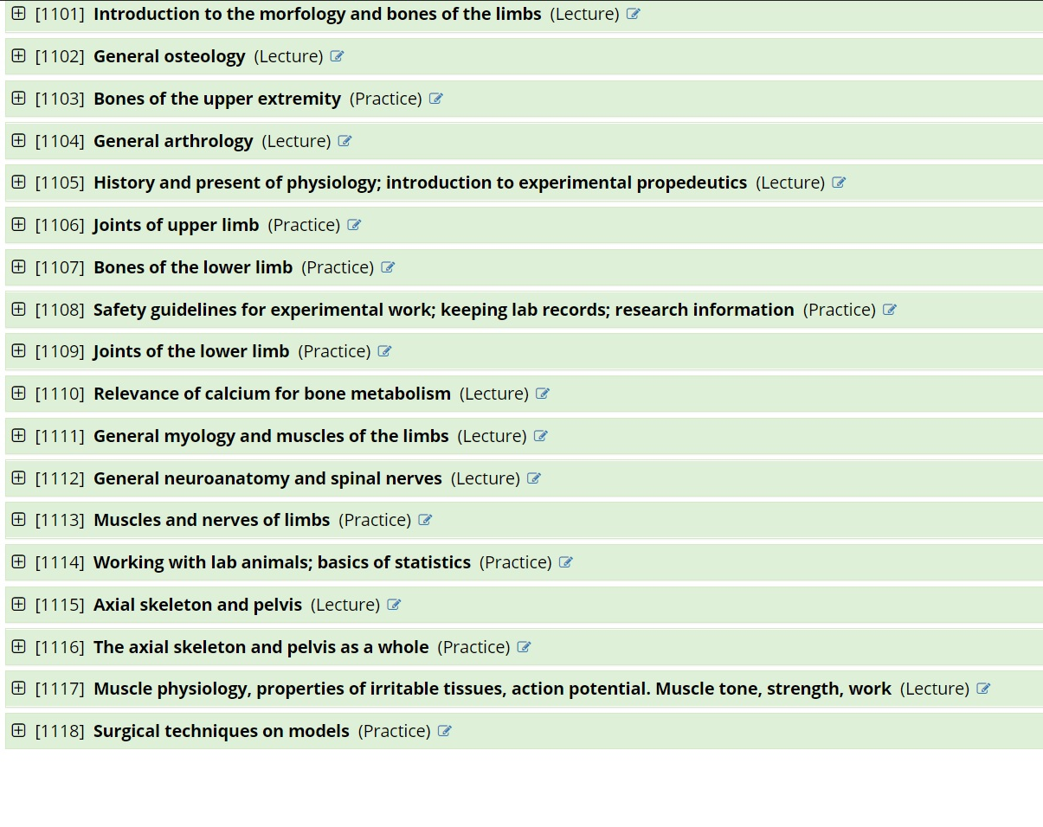
Příklad úpravy k jednotce 1113:
- muscles of the shoulder and shoulder blade (practical demonstration of the muscles according to the groups - origin, insertion, function)
b) muscles of the arm (practical demonstration of the muscles according to the groups - origin, insertion, function)
c) muscles of the forearm (practical demonstration of the muscles according to the groups - origin, insertion, function)
d) muscles of the hand (practical demonstration of the muscles - origin, insertion, function)
e) course of vessels and nerves
f) basic topography of the upper limb (axilla, fossa cubitalis, canalis carpalis et ulnaris, foveola radialis)
g) clinical applications (rotator cuff, carpal tunnel syndrome and other tunnel syndromes, paralysis)
h) muscles of the hipjoint (practical demonstration of the muscles - origin, insertion, function)
i) muscles of the thigh (practical demonstration of the muscles - origin, insertion, function)
j) muscles of the leg (practical demonstration of the muscles - origin, insertion, function)
k) muscles of the foot (practical demonstration of the muscles - origin, insertion, function)
l) course of vessels and nerves
m) basic topography of the lower limb (lacuna vasorum et musculorum, trigonum. femorale, fossa iliopectinea, fossa poplitea, canalis tarsalis)
n) cervical plexus and its main motor and sensory nerves
o) brachial plexus, division into supra and infraclavicular parts, main nerves and muscles supplied
p) thoracic spinal nerves and their arrangement with respect to intercostal space
r) sacral plexus, main branches, supplied muscle groups, topography
s) basic innervation disturbances
k) clinical application (intramuscular injections, pulse rate measuring, tunnel syndromes
Toto dílo podléhá licenci Creative Commons licenci 4.0 Mezinárodní Licence.

